**Frontend Inspirations**

* <https://www.allrecipes.com/>
  + Clean Layout: The website has a clean and organized layout, with clear navigation menus, making it easy for users to find what they're looking for.
  + High-Quality Imagery: Allrecipes uses high-quality images for recipes, which are visually appealing and help users envision the final dish.
  + User-Generated Content: The website prominently displays user-generated content, such as ratings, reviews, and photos, which enhance credibility and trustworthiness.

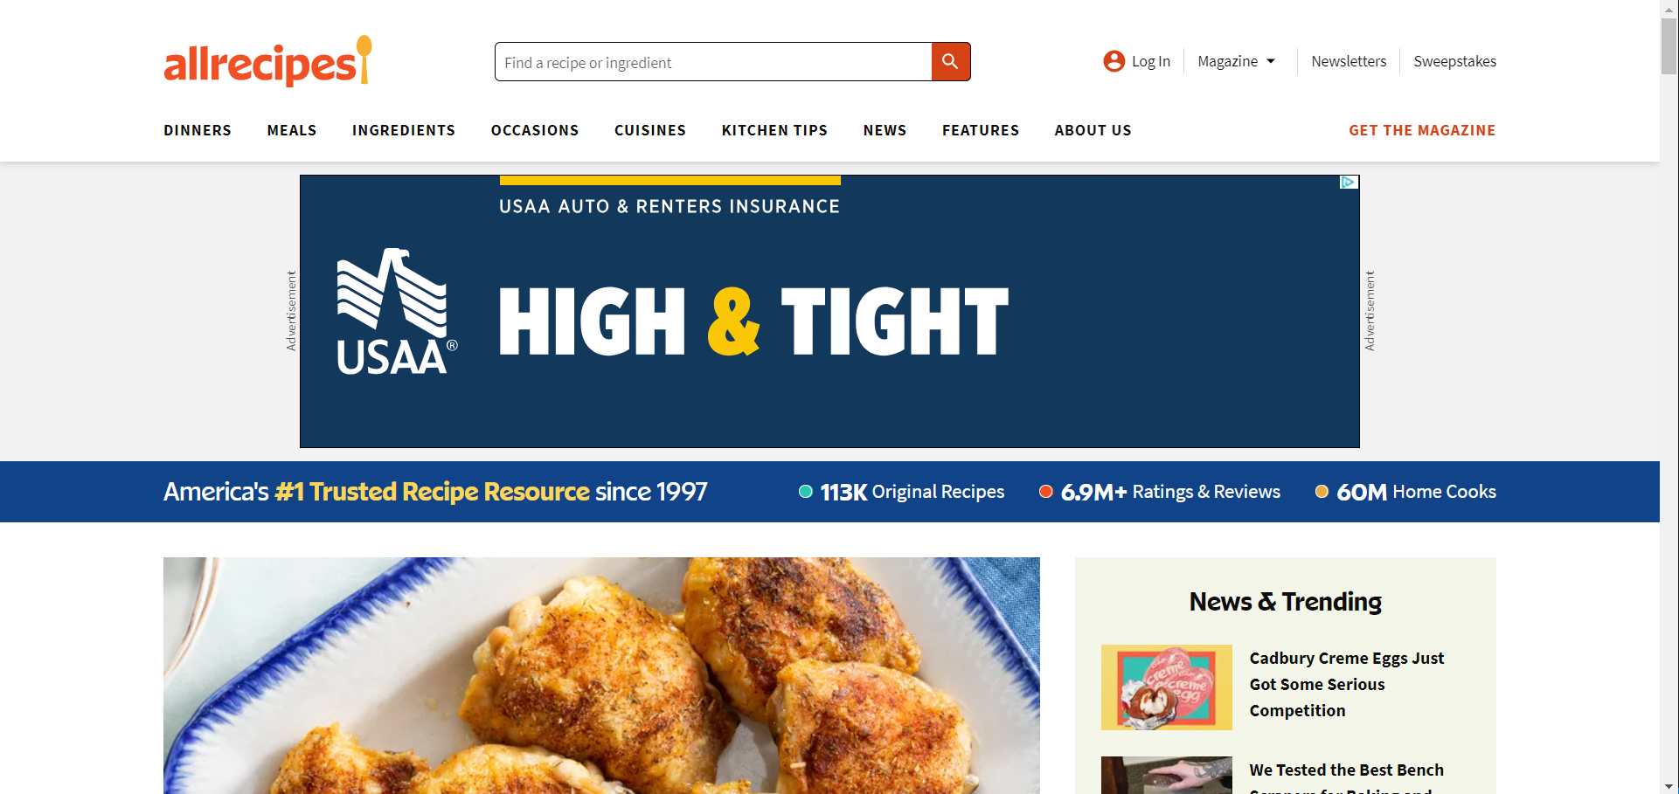

* <https://www.simplyrecipes.com/>
  + Clean and Minimalistic Design: The website employs a clean and minimalistic design, with ample white space, making it visually appealing and easy to navigate.
  + Focus on Content: Simply Recipes places a strong emphasis on its content, with large, high-quality images accompanying each recipe, enticing users to explore further.
  + Clear Navigation: The website features clear and intuitive navigation, with well-organized categories and menus, enabling users to quickly find recipes of interest.

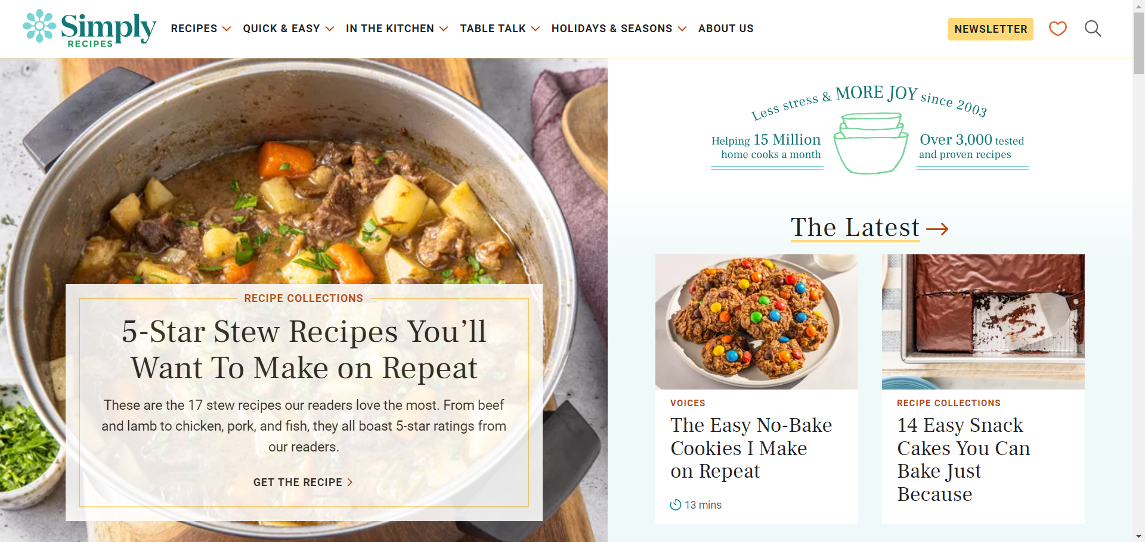

* <https://www.epicurious.com/>
  + Sleek and Modern Design: The website features a sleek and modern design aesthetic, with a clean layout and sophisticated typography, creating a visually pleasing experience.
  + Vibrant Imagery: Epicurious utilizes vibrant and high-quality images to showcase recipes, ingredients, and finished dishes, enticing users to explore further.
  + Featured Content: The homepage often highlights featured recipes, articles, and culinary trends, drawing users' attention to popular or seasonal content.

